

7th Framework Programme
SST.2013.4-2. Inspection Capabilities for Enhanced Ship Safety
Collaborative Project
DOCUMENT ID
SAFEPEC|D|2.1|DT|2016.09.30|V|01

due date of deliverable
2016-09-30

actual submission date
[Publish Date]

dissemination level
CO (Confidential, only for the member of the consortium, including Commission Services)
Deliverable 2.1
WP 2.1: ???

7th Framework Programme
SST.2013.4-2. Inspection Capabilities for Enhanced Ship Safety
Collaborative Project

Deliverable 2.1
WP 2.1: ???

AUTHORSHIP
Author(s) | [TITLE] [NAME] [ACRONYM], [TITLE] [NAME] [ACRONYM]
Beneficiary Partner | [ACRONYM]
Issue Date | YYYY-MM-DD
Revision
Status
Contributors | [TITLE] [NAME] [ACRONYM], [TITLE] [NAME] [ACRONYM]
Pages
Figures
Tables
Annexes

SIGNATURES
Author(s)
Coordinator

Disclaimer

The information contained in this report is subject to change without notice and should not be construed as a commitment by any members of the SAFEPEC Consortium or the authors. In the event of any software or algorithms being described in this report, the SAFEPEC Consortium assumes no responsibility for the use or inability to use any of its software or algorithms.

The information is provided without any warranty of any kind and the SAFEPEC Consortium expressly disclaims all implied warranties, including but not limited to the implied warranties of merchantability and fitness for a particular use.

(c) COPYRIGHT 2014 The SAFEPEC Consortium

This document may be copied and reproduced without written permission from the SAFEPEC Consortium. Acknowledgement of the authors of the document shall be clearly referenced. All rights reserved.

Deliverable 2.1
WP 2.1: ???

REVISION
Revision Date | Reviewer Name | Reviewer Signature
YYYY-MM-DD | [TITLE] [NAME] [ACRONYM]

HISTORY
Version Date | Version Id | Status | Comment
YYYY-MM-DD | V0.0 | [DRAFT] | [BRIEF DESCRIPTION OF THE REVISION]
YYYY-MM-DD | V0.0 | [DRAFT] | [BRIEF DESCRIPTION OF THE REVISION]
YYYY-MM-DD | V1.0 | [FINISH] | [BRIEF DESCRIPTION OF THE REVISION]

Deliverable 2.1
WP 2.1: ???

Abstract
Lorem ipsum dolor sit amet, consectetur adipiscing elit. Pellentesque porttitor quam ac lobortis ultricies. Donec porttitor fermentum porta. Etiam eget tempor nisl. Nunc nec dui odio. Phasellus pretium lacus et leo pellentesque, ut sagittis dui viverra. Sed malesuada ultricies mollis. Cras vitae ligula id orci imperdiet porta fringilla ac justo. Duis at enim dignissim, viverra nisl quis, molestie libero. Nullam vel purus eu lectus condimentum vulputate. Phasellus dolor sapien, vestibulum in lorem vitae, posuere pretium neque. Ut blandit volutpat justo. Aliquam condimentum vel felis sed rhoncus. Integer lobortis ut elit quis pharetra. Curabitur feugiat vulputate mattis. In nisl enim, dapibus in posuere at, faucibus ut ipsum.
Proin vitae purus nec mauris scelerisque tempus. Nunc dictum eget mauris at fringilla. Donec rutrum massa molestie euismod suscipit. Vestibulum scelerisque dignissim lacus, non bibendum dolor scelerisque vel. Vivamus fermentum, neque at luctus elementum, orci metus vulputate nunc, sed dictum quam nibh eleifend est. Ut mollis gravida fermentum. Integer et ligula nulla. Pellentesque eu ligula enim. Vestibulum urna odio, auctor sit amet ipsum sit amet, molestie porttitor elit. Nam a.

Summary Report

Introduction
Lorem ipsum dolor sit amet, consectetur adipiscing elit. Pellentesque porttitor quam ac lobortis ultricies. Donec porttitor fermentum porta. Etiam eget tempor nisl. Nunc nec dui odio. Phasellus pretium lacus et leo pellentesque, ut sagittis dui viverra. Sed malesuada ultricies mollis. Cras vitae ligula id orci imperdiet porta fringilla ac justo. Duis at enim dignissim, viverra nisl quis, molestie libero. Nullam vel purus eu lectus condimentum vulputate. Phasellus dolor sapien, vestibulum in lorem vitae, posuere pretium neque. Ut blandit volutpat justo. Aliquam condimentum vel felis sed rhoncus. Integer lobortis ut elit quis pharetra. Curabitur feugiat vulputate mattis. In nisl enim, dapibus in posuere at, faucibus ut ipsum.
Proin vitae purus nec mauris scelerisque tempus. Nunc dictum eget mauris at fringilla. Donec rutrum massa molestie euismod suscipit. Vestibulum scelerisque dignissim lacus, non bibendum dolor scelerisque vel. Vivamus fermentum, neque at luctus elementum, orci metus vulputate nunc, sed dictum quam nibh eleifend est. Ut mollis gravida fermentum. Integer et ligula nulla. Pellentesque eu ligula enim. Vestibulum urna odio, auctor sit amet ipsum sit amet, molestie porttitor elit. Nam a.

Deliverable 2.1
WP 2.1: ???

List of Contents
Abstract 2
Summary Report 2
1 INTRODUCTION 10
2 EXECUTIVE SUMMARY 13
2.1 Details 13
3 Data Integration 14
3.1 Ontologies in data integration 14
4 Use Cases 17
4.1 Runtime Use Case 17
4.2 Set Evidence Use Case 18
4.3 Get Vessel Specific Attribute Values 18
4.4 Develeopment Time Use Case 19
4.5 Edit Risk Model Parameter Tables 19
4.6 Summary 19
5 Role of DIM in the runtime use Case 21
6 Something About Implementation 25
6.1 Interface to call DIM 25
6.2 Interface to data sources 26
6.3 Look inside DIM 27
7 Designing the ontology 29
7.1 Notation 29
7.2 Ontology Design Principles 29
7.2.1 Link to other ontologies 29
7.2.2 OWL 2 QL 30
7.2.3 Resolve database records to domain concepts by -ontop- mappings 30
7.2.4 Ensure consistency 30
7.3 Competency Questions 30
7.4 Ontology Explained 31
7.4.1 model 32
7.4.2 dependent 33
7.4.3 data_item 36
7.4.4 parameter 37
7.4.5 parameter_definition 38
7.5 Testing the ontology 39
7.5.1 Sample individuals 39
7.6 SPARQL queries 41
7.6.1 Competency Questions CQ-a 41
7.6.2 Competency Question CQ-b 42
7.6.3 Competency Question CQ-c 43
7.6.4 Competency Question CQ-d 44
7.6.5 Competency Question CQ-e 44
7.6.6 Competency Question CQ-f 46
7.6.7 Runtime SPARQL 46
7.7 Summary 48
8 References 50

Deliverable 2.1
WP 2.1: ???

List of Tables
No table of figures entries found.

Deliverable 2.1
WP 2.1: ???

List of Figures
Figure 1 Illustration of unified risk model, refer to (Nina Kähler, 2016) 10
Figure 2 11
Figure 3 A Brief History of the Semantic Web, refer to (N. Bikakis, 2013) 15
Figure 4 A model of semantic Web components and how they fit together, refer to (Lowndes, 2006) 16
Figure 5 UML use case diagram showing the main use cases for DIM 17
Figure 6 Visualization of the Risk Management Framework, refer to WP 4. 21
Figure 7 Graphical representation of corrosion cause model, refer to D 5.1, figure 3-4 22
Figure 8 Simplified hierarchy scheme of sub-models and leaf-models assembling to the risk assessment model 23
Figure 9 Citation from D 5.1, table 3-2: Weighting of parameters influencing coating lifetime (first 5 rows) 23
Figure 10 Rough building block view of the DIM neighbourhood inside a possible Safepec software application 25
Figure 11 Simplified sub-model hierarchy as applied in the sample statements, refer to Figure 8 26
Figure 12 On-the-fly approach to OBDA (Muro, 2013) 28
Figure 13 Component view of DIM 29
Figure 14 Introduction to OntoGraf visualization provided by Protégé 30
Figure 15 Basic UML class diagram of the Safepec data integration data model 32
Figure 16 Class hierarchy of Safepec ontology as presented by Protégé 33
Figure 17 Object property definitions of Safepec ontology in turtle syntax. 34
Figure 18 Class hierarchy of model. 35
Figure 19 Class hierarchy of dependent 35
Figure 20 Definition of causes_corrosion/cargo_dependent as visualized by Protégé 36
Figure 21 Definition of causes_corrosion/cargo_dependent in turtle notation 36
Figure 22 Definition of causes_corrosion/cargo as visualized by Protégé 37
Figure 23 Definition of causes_corrosion/cargo in turtle notation 37
Figure 24 Definition of causes_corrosion/coating_lifetime as visualized by Protégé 37
Figure 25 Definition of causes_corrosion/cargo in turtle notation 37
Figure 26 Class hierarchy of data_item 38
Figure 27 Sample table from Safepec database representing the data necessary to quantify the class node of Figure 7 38
Figure 28 Screenshot on sample individuals from Protégé: parameter, data_item, parameter_definition representing one row of the table in Figure 25 39
Figure 29 Definition of the parameter_defintion sub-class causes_corrosion/class_pd in turtle notation 40
Figure 30 Overview on classes of sample individuals 42
Figure 31 Sample individual “set 2”, turtle notation 43
Figure 32 Prefix definitions for the SPARQL queries 43
Figure 33 SPARQL code to CQ-a 43
Figure 34 Result set to CQ-a 44
Figure 35 SPARQL code to CQ-b 44
Figure 36 Result set to CQ-b 45
Figure 37 SPARQL code to CQ-c 45
Figure 38 Result set to CQ-c 45
Figure 39 SPARQL code to CQ-d 46
Figure 40 Result set to CQ-d 46
Figure 41 SPARQL code to CQ-e 47
Figure 42 Result set to CQ-e 47
Figure 43 SPARQL code to CQ-f 48
Figure 44 Result set to CQ-f 48
Figure 45 SPARQL code to runtime SPARQL 50
Figure 46 Result set to runtime SPARQL for ?model_class = causes_corrosion/class 50
Figure 47 Result set to runtime SPARQL for ?model_class = causes_corrosion/coating_lifetime 50

Deliverable 2.1
WP 2.1: ???

List of Glossary
Ontology: "A representational artefact, comprising a taxonomy as proper part, whose representations are intended to designate some combination of universals, defined classes, and certain relations between them". Refer to (Robert Arp, 2015)
RDF Statement: A subject-predicate-object expression about resources (in particular web resources)
RDF Store: A RDF store is a database for RDF data.
Triple Store: Refer to RDF Store
Deliverable 2.1
WP 2.1: ???

List of Abbreviations
AIS | Automatic Identification System
BN | Bayesian Network
CPT | Conditional Probability Table
CPT | Conditional Probability Distribution
DIM | Data Integration Module
DL | Description Logic
DoW | Description of Work
HMI | Human Machine Interface
IACS | International Association of Classification Societies
IMO | International Maritime Organization
OBDA | Ontology-Based Data Access
OWL | Web Ontology Language
PSC | Port State Control
RDBMS | Relational Database Management System
RDF | Resource Description Format
RDF-S | RDF Schema
SPARQL | SPARQL Protocol And RDF Query Language
SQL | Structured Query Language
URI | Unique Resource Identifier
WP | Work Package (of the project)
XML | Extensible Mark-up Language

INTRODUCTION
The aim of SAFEPEC is to develop a methodology for identifying ships for inspection and survey by means of risk.
“Work Package 5 (WP5) of SAFEPEC implements the 4 parts of the unified risk model, as illustrated in the Figure below: Cause, Vulnerability, Consequence and Inspection modules.” Refer to (Nina Kähler, 2016)

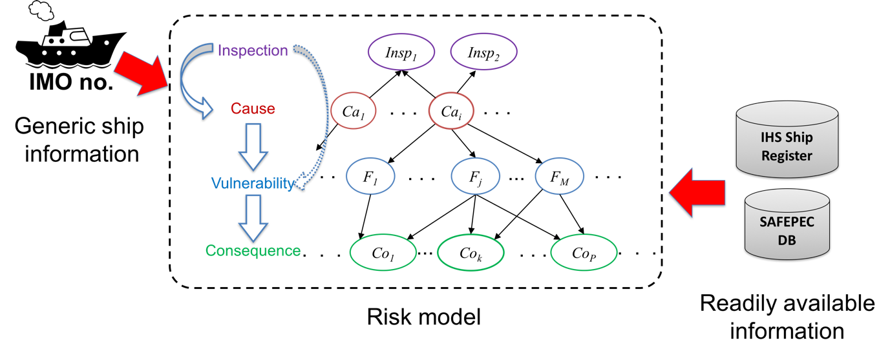
Figure 1 Illustration of unified risk model, refer to (Nina Kähler, 2016)
It is the role of Work Package 2 (WP2) to ensure interoperability in data exchanges and consistent interpretation of data used in other WPs. This is necessary to correctly link casualties, near-misses and ship deficiencies data to risks, both for historic data analysis and for improved risk analysis and inspection procedures.
“The developed risk model is applicable with readily available information, e.g. ship type, age, size, flag, class, and so on. Therefore, the developed models are physically-based generic models which are formulated in function of available indicators without detailed knowledge and models of the specific ship.” Refer to (Nina Kähler, 2016)
As can be seen from Figure 1 and the citation from D5.1 above, the developed risk model relies on the availability of certain data, i.e. generic ship information and available indicators to calibrate the generic risk model to a specific ship.
Thus, the final result of WP2 is an integration tool (namely a data integration module DIM) which provides the central access point to all data required to evaluate the unified risk model, see Figure 2.

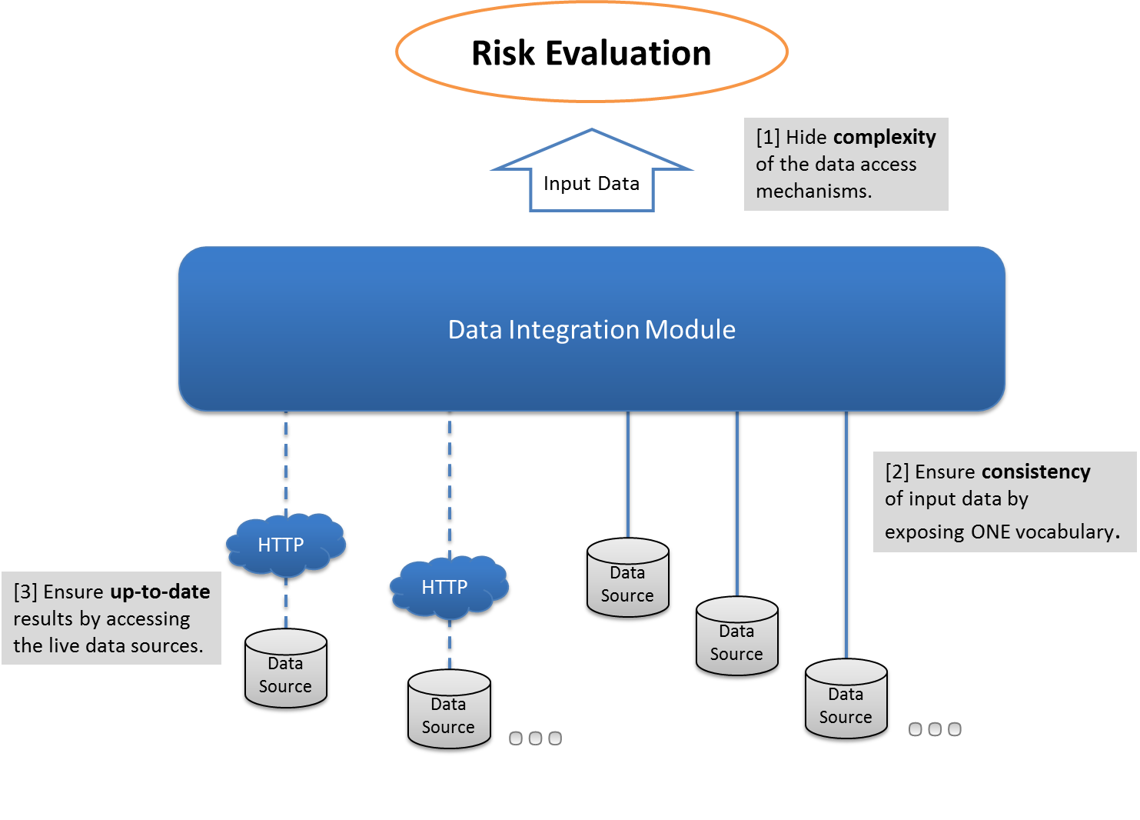
Figure 2
As stated in Figure 2, the DIM is based on three quality concerns, namely:
[1] Hiding complexity: In SAFEPEC's overall risk framework, the provision of input data to the risk evaluation is delegated to some central DIM. Thus, the concerns of evaluating the risk and acquiring the necessary input data are clearly separated. The DIM has to use the vocabulary of its target domain, i.e. the unified risk model. With fulfilling this requirement, the complexity of the actual data sources is completely hidden from the risk model.
[2] Ensuring consistency: For the risk model it is crucial to execute on valid input data. It is the responsibility of the DIM to ensure, that the input data to the risk model is consistent with respect to the ONE vocabulary the DIM exposes.
[3] Ensuring up-to-date results: Since the data sources to be integrated by DIM are alive with respect processes outside SAFEPEC (e.g. the PSC database is continuously updated with new inspection and detention data), the risk evaluation has to execute on up-to-date information. Thus, the DIM has to be designed such that it allows for live access to data sources which are subject to data changes outside SAFEPEC.
In Task 2.1 of WP2, the data integration vocabulary to provide the input to the risk model for risk evaluation is prepared. The approach to data integration and the basic formal vocabulary itself are reported by this document.
It starts with an introduction to ontology-based data integration (see section ‎3). Since the final target of WP2 is a prototype implementation of the DIM, it is important to analyse the target domain also in this respect. Therefore, the use cases to a DIM software component have been documented, see section ‎0. Since the SAFEPEC consortium decided to focus on the actual risk evaluation as the primary scenario, the implications for such a use case are discussed in section ‎5. To account for the planned implementation by task 2.3, the boundary conditions arising to the design of the vocabulary from this side are reported in section ‎6. The basic formal SAFEPEC vocabulary is finally presented by section ‎7.
In task 2.2 of WP2, the vocabulary of task 2.1 will be complemented with the specific terms used by the risk model. The results will be reported by D2.2.
In task 2.3 of WP2, a prototype of DIM will be implemented.

EXECUTIVE SUMMARY
The reliability of a risk evaluation at a certain time with respect to a certain list of ships strongly depends on the quality of the risk model (refer to WP 5) and the quality of the input data. The latter is driven by its up-to-datedness and its consistent interpretation.
In this work package procedures are developed to ensure access to the most recent ship data from external data sources and a consistent interpretation of the data by means of a harmonised vocabulary. The final outcome is a software prototype for integrating several ship data sources relevant to the evaluation of the risk models into one consistent system called the SAFEPEC Data Integration Module (DIM).

Details
The aim of a data integration layer is to hide the complexity of several independent data sources and provide access to the data by a domain specific vocabulary. This enables domain experts to use the data up to their potential.
For the domain of probability based risk models, the terms from the risk models itself thus need to be a core part of the vocabulary as they represent the language of the domain experts. The data model (ontology and taxonomy as representation of the domain vocabulary) of the data integration module thus mirrors the Bayesian Networks which encode the risk models. The overall scope of the data to be integrated by the vocabulary is clearly defined by this setup. Among other things, it covers main particulars of the ship, administrative data (e.g. classification society or flag state), operational data (e.g. cargo or operational area), and condition data (e.g. deficiencies or survey ratings).
At runtime of a Safepec risk analysis, the Data Integration Module acquires the required facts about the ships to be assessed from the external data bases. By these vessel specific facts, the Data Integration Module provides the correct configurations of the risk models (i.e. conditional probability distributions of the dependent Bayesian Network nodes) from the Safepec Database. In the same way, it provides risk related quantifications (i.e. the evidences for the independent Bayesian Network nodes) for the ship specific facts.
Moreover, the Data Integration Module can be used by domain experts to carry out analyses of historic data in order to develop and (re-)calibrate a risk model. The results of such a development step are stored as expert knowledge inside the Safepec Database and thus available for any further Safepec risk analysis.

Data Integration
According to (Underdahl, 2014) “data integration refers to an industry and a technology designed to make it easy for you to combine different sources of data together to produce useful business information. Those sources may include legacy mainframe databases, modern relational databases, desktop applications, social media comments, blog postings, machine sensor data, and so on." Thus, the task of integrating data covers
- data, which is physically stored in different places
- data, which is physically provided in different representations (relational table, xml file, web post, etc.)
- data of different structure (i.e. data model)
- data of different level of structuration (structured, semi-structured, unstructured)
Applying the definitions above, the main task of the DIM can be named to a data integration task.
The challenges to data integration are often summarized by three to five V's as follows:
- volume
- velocity
- variety
- veracity
- value
While volume and velocity can today be treated the right infrastructure (e.g. based on hadoop, refer to (hadoop, 2016)), variety and veracity are challenges that have to be approached for each project individually. A fifths V keyword, is value, i.e. the ability to turn the integrated data into something of value, refer to (Underdahl, 2014). Since the value V is addressed by the SAFEPEC project goals, the focus for WP2 and the data integration module lies on variety (i.e., hiding complexity) and veracity (i.e., ensuring consistency).
Addressing variety and veracity involves business experts as well as IT professionals. The traditional way of collaboration involves a specification by business experts and an implementation by IT professionals. In this scenario, both parties can only be sure, they understood each other correctly, at the very end of the project, when the final result is handed over. In big and complex projects (as data integration projects usually are), this is a serious risk.
In order to manage this risk, tools used for data integration try to
- visualize, how data from the data sources are integrated
- clearly document the definitions and relationships of data items
- follow up on the consequences of changes in the source data to the outcome
For SAFEPEC, it was decided to base the data integration on an OWL ontology, refer to SAFEPEC description of work for WP2. Considering the facts above, this approach is well suited for the task and comes along with a set of tools and techniques to address the above mentioned risks.

Ontologies in data integration
“Data sources can be heterogeneous in syntax, schema, or semantics, thus making data interoperation a difficult task (Bishr, 1998). Syntactic heterogeneity is caused by the use of different models or languages. Schematic heterogeneity results from structural differences. Semantic heterogeneity is caused by different meanings or interpretations of data in various contexts. To achieve data interoperability, the issues posed by data heterogeneity need to be eliminated.
…
We call semantic data integration the process of using a conceptual representation of the data and of their relationships to eliminate possible heterogeneities. At the heart of semantic data integration is the concept of ontology, which is an explicit specification of a shared conceptualization (Gruber, 1993), (T. R. Gruber, 1994). “ Refer to (Isabel F. Cruz, 2005).
With the introduction and standardization of RDF, RDF Schema and OWL, see Figure 3, the relevance of ontologies in the field of data integration and the semantic web increased significantly, e.g. (Dean Allemang, 2008). By the standards named above, the formal description of a domain by ontology got executable.
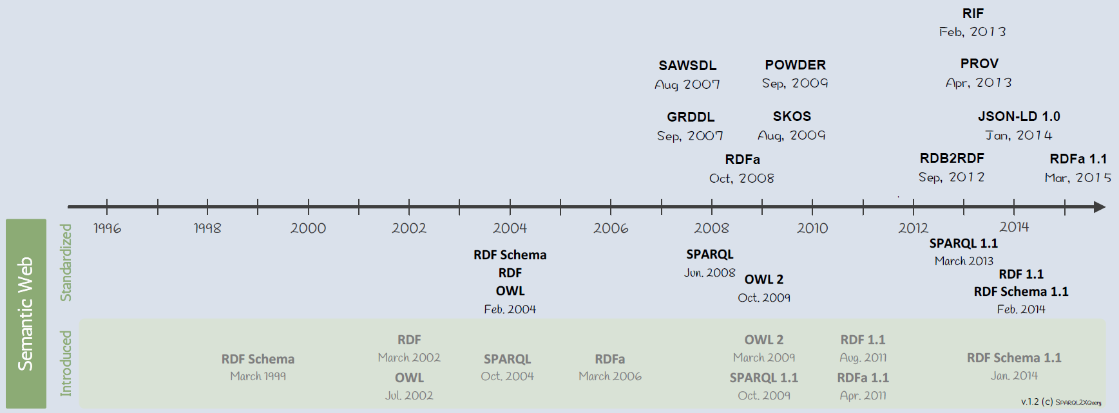
Figure 3 A Brief History of the Semantic Web, refer to (N. Bikakis, 2013)
Figure 4 gives an overview on the components acting in such an ontology-based data integration scenario. A digital object (identified by an URI) has associated metadata represented as RDF. These RDF statements make use of concepts described by an OWL ontology. The digital object can thus be classified by means of this OWL ontology. The classification can be supported by additionally inferred RDF statements arising from the logic inside the OWL ontology. The inferences are drawn by components named OWL reasoners. With applying further ontologies to the digital object, it is classified, i.e. described, with respect to these other ontologies. Querying such data is done by SPARQL.

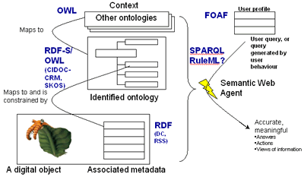
Figure 4 A model of semantic Web components and how they fit together, refer to (Lowndes, 2006)
WP2 aims for an ontology to describe the terms and parameters required for a risk assessment according to WP5. Additionally, this ontology will be linked to other known ontologies to make the data ruled by this ontology meaningful to a broader public.

Use Cases
From the risk evaluation point of view, there are two scenarios for accessing data from the external data sources.
The first scenario is a runtime scenario, see Figure 5. Given a Safepec risk evaluation software, to execute the risk module for a specific vessel, the risk model has to be adjusted to the characteristics of the respective vessel. This adjustment of the risk model happens by setting the risk model parameters to vessel specific values. The parameter values are maintained in Safepec's parameter database. From here, they are looked up by keys specific to the risk (sub-)module. The values to the keys are vessel specific properties to be obtained from external data sources like IHS Ship Register. The details of this scenario are presented by the runtime use case in section … below.
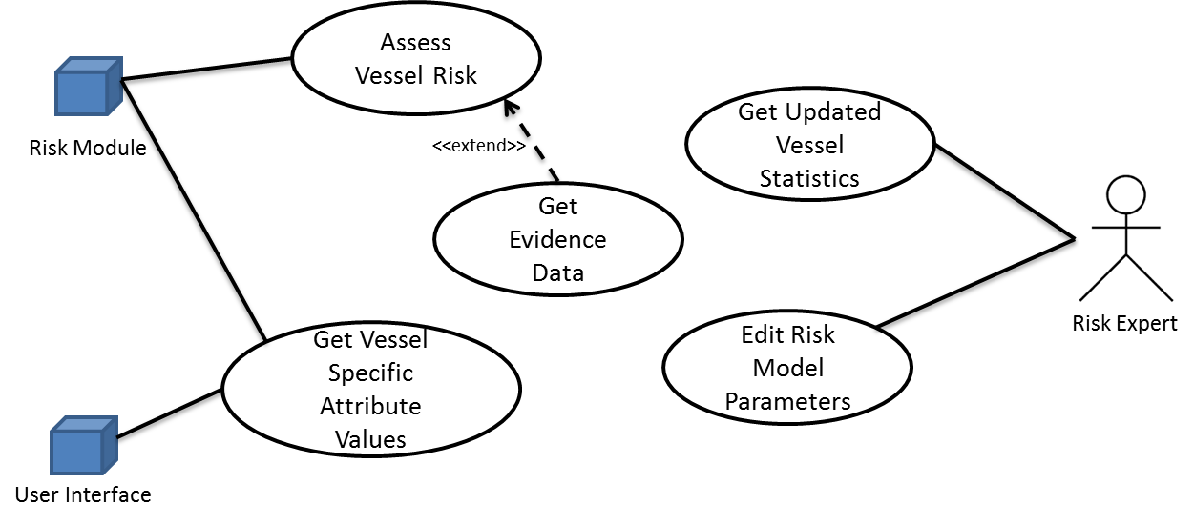
Figure 5 UML use case diagram showing the main use cases for DIM
The second scenario is a development time scenario. It affects the setup of the risk model parameters. These parameters represent the knowledge encoded in the Safepec risk models. The parameter values are gained from statistical analyses based on available vessel data (i.e. AIS, Port State, etc.). Since the results of the statistical analyses are quite stable over time, for Safepec the parameter values are stored with a parameter database and only updated from time to time. The details of this scenario are presented by the developement time use case in section … below.

Actors
…

Risk Assessment Use Case
Title | Get vessel specific parameter values to quantify a risk model or a sub-model
Primary Actor | risk module
Goal in Context | Being able to populate the risk model with the parameters applying to the given vessel. This corresponds to a specification of the risk model to the properties of the respective vessel.
Scope | Risk evaluation for a given vessel
Preconditions | - An external database is reachable, which provides identification and attributes of the vessel.  - The risk model is known in the context of DIM, i.e., the lookup of the risk model parameters can be completely resolved by the DIM.
Trigger | Risk module calls. This will happen for every vessel the risk has to be evaluated for. Each time a user uses the systems, he will evaluate risks for a list of vessels (~ 5 to 100).
Main Success Scenario | Step 1: Identify the vessel from the external data sources.  Step 2: Identify the vessel data relevant to the given risk model.  Step 3: Get values for the relevant risk model parameters based on the vessel and its data.
Extensions | Extension 1: Get evidence data for probability variable of some probability model.

Set Evidence Use Case
Title | Get evidence data for probability variable of some probability model
Primary Actor | Risk module
Goal in Context | With the probability models (e.g. Bayesian networks, fault trees), there may be nodes to which the state for a specific vessel is known (or evident). The goal of this use case is to identify, whether there are probability variables to which the state is known for the given vessel and the value for this state.
Scope | Risk evaluation of given vessel with known data (e.g. condition data, route data). This use case may apply, if there are actual inspection results available (WP 5.4) for a vessel or integrity information from sensor measurements (WP 7).
Preconditions | - The vessel is known in the context of DIM.  - An external data source with evidence data for the respective vessel is reachable for DIM.  - The lookup of the evidence data for a probability variable is encoded by the DIM.
Trigger | On execution of the runtime use case.
Main Success Scenario | Step 1: Identify vessel specific data source  Step 2: Get result set with available evidence data from the data source
Extensions | --

Get Vessel Specific Attribute Values
Title | Get Vessel Specific Attribute Values
Primary Actor | Risk module
Goal in Context | In order to evaluate some details (vulnerability module) during the risk analysis, some values of vessel attributes (main particulars) are required. Additionally, the HMI needs to display some vessel specific attributes as background information to the user.
Scope | Risk evaluation for a given vessel
Preconditions | - The vessel id is known and the external data sources providing the attributes are reachable.
Trigger | Risk module or HMI calls. This will happen every time and for every vessel that a risk has to be evaluated.
Main Success Scenario
Extensions | --

Develeopment Time Use Case
Title | Get statistical data in the domain of vessel integrity
Primary Actor | Safepec Risk Expert
Goal in Context | Get all statistical data that is required to repeat the expert analysis for obtaining the risk model parameter values.
Scope | Update of risk model parameter tables
Preconditions | - External databases containing the required data related to vessel integrity are reachable.  - The relationship between risk model parameter and vessel integrity data constituting its values is encoded in the DIM.
Trigger | The trigger is under discussion. It can be a time trigger (e.g. every 6 months) or an action triggered by a user (e.g. user of Safepec solution or the Safepec risk expert).
Main Success Scenario
Extensions | --

Edit Risk Model Parameter Tables
Title | Edit Risk Model Parameter Tables
Primary Actor | Safepec Risk Expert
Goal in Context | The Safepec risk expert edits the parameters of his/her risk module in the provided tables.
Scope | Update of risk model parameter tables
Preconditions | - The Safepec Risk Expert is authenticated by the table admin app.  - The table to be changed is visible to the safepec risk expert.
Trigger | The safepec risk expert invokes the editing of the table.
Main Success Scenario
Extensions | --

Summary
Same as the DoW, the lis tof use cases indicates that the clear ambition of WP 2 has to be to integrate and provide the data required by the risk modules. Thus, the focus of the next chapter is the description and discussion of the chosen approach to data integration.
In order to support the overall goal of the Safepec project to be able to actually run a risk evaluation live, the focus for WP 2 is laid on the runtime use case and the supporting use case for getting vessel specific attribute values. The two remaining use cases are concerning the updating of the risk model parameter tables. Answering the runtime use case by the DIM, means to save part of the knowledge of the risk modules (it can only be a part of the knowledge as long as the evaluation of the actual risk model parameters depends partly on expert judgement). They are presented in D2.1 for the sake of completeness, since the ability to store at least a part of the Safepec knowledge digitally is a crucial aspect. But they will not be part of the implementation of the Safepec solution, since this would be a concurring goal with the runtime use cases in terms of time and budget.

Role of DIM in the runtime use Case
In order to evaluate the overall risk of a vessel with respect to life, property, environment (further on denoted as "risk") several aspects of risk, the vessel itself and operations or circumstances of the vessel that affect the risk have been modelled by WP 4 and WP 5. The result is one risk management framework with a risk module implementing a risk assessment model as the heart of it (see Figure 6). The risk framework incorporates different modules each contributing a different aspect to the overall risk assessment evaluation (i.e. causes, vulnerabilities, consequences). Same as the risk module itself, every sub-module is based on some mathematical or calculation model of the actual aspect of concern. In the following, all these models will be referred to as the risk models.
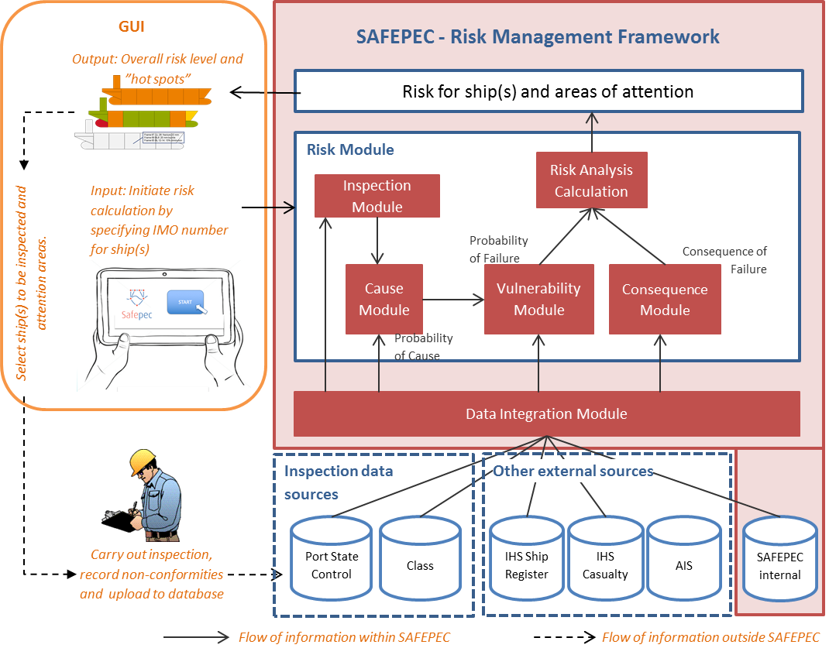
Figure 6 Visualization of the Risk Management Framework, refer to WP 4.
Building a model means to create an abstract representation of an aspect or object of the real world for a specific purpose. The representations used to establish the model can be e.g. graphical, mathematical, physical or verbal. The above statement also holds for the risk assessment model developed by this project. In WP 4 and WP 5 of this project, mathematical representations have been chosen to prepare the risk model and all of its sub-models and sub-sub-models as there are for instance corrosion cause, coating cause, or bending capacity vulnerability.
Different mathematical approaches have been used to model the relevant aspects of the risk as there are
- Bayesian networks (e.g. for the causes originating from corrosion and fatigue)
- Fault trees (e.g. for causes originating from life-saving appliances LSA)
- Response surfaces (e.g. for ultimate moment capacity of a vessels mid-section used by the vulnerability model)
All these models and sub-models have the purpose to quantify either the risk itself or some aspect contributing to the final evaluation of the risk. Such an aspect can be itself quite complex and worth an own (sub-)model such as causes or even the cause-corrosion (see Figure 7.) But it can also be small with respect to the overall target and thus only be represented by a BN node (e.g. the quality of the maintenance regime) or even only some mathematical equation.

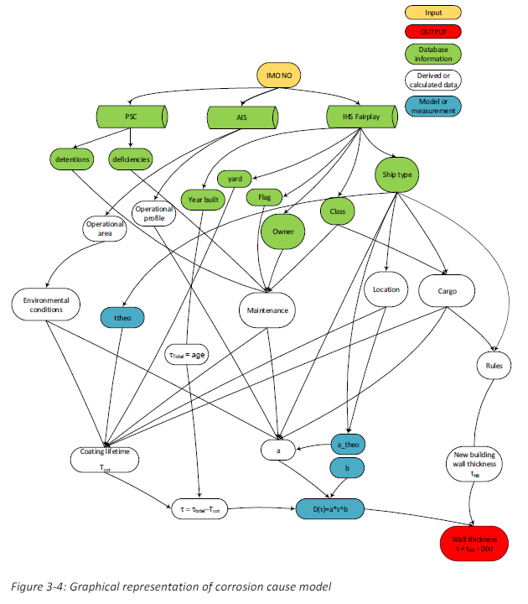
Figure 7 Graphical representation of corrosion cause model, refer to D 5.1, figure 3-4
In the perception of WP 2 (data integration), the low level sub-models (leaf-models) are the aspects to contribute to. In the case of the corrosion cause model shown in Figure 7, the leaf models in the sense of WP 2 are the BN nodes representing derived and calculated data (white), which receive database information (green). If the DIM provides all data necessary to evaluate the leaf models, then it is the capability and responsibility of the risk module to wire up all the intermediate results from the sub- models to the envisaged overall risk, see hierarchy of models in Figure 8.
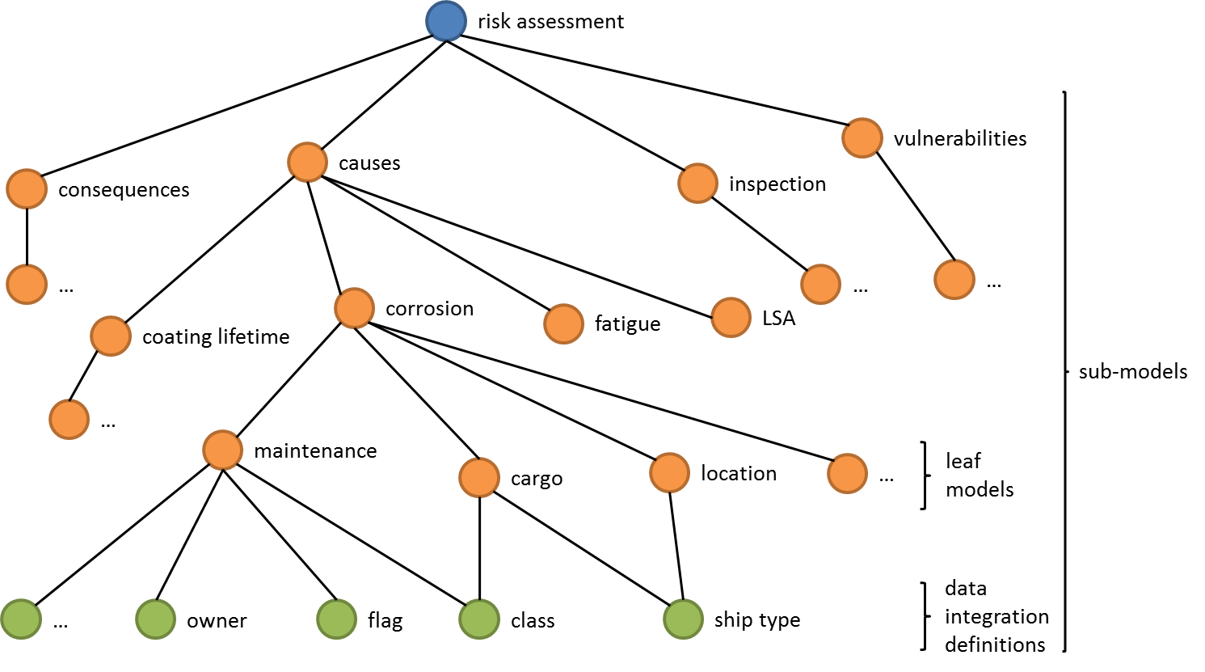
Figure 8 Simplified hierarchy scheme of sub-models and leaf-models assembling to the risk assessment model
It is important to understand, that for the data integration the green BN nodes carrying the database information (see Figure 7) are a part of the overall model, as well. They are no mathematical models as the other sub-models. They are some concepts, definitions or groupings that provide the link between the actual data available from the real data source and the value required by the leaf-model. Actually, these two are NOT the same! In the following, this special type of sub-model will be called data integration definitions.
For the runtime use case, it is the responsibility of the data integration module to provide the correct values at the data integration definitions.
In order to illustrate the task of the data integration definitions, "class" from figure … or figure …, respectively, is taken for an example.
From D5.1 table 3-2 (refer to Figure 9), it can be seen, that the value for "class" (or "Building class" respectively)
- is some abstract factor to quantify the impact of the ships classification society on the coating lifetime
- depends on the IACS membership status of the ships classification society.
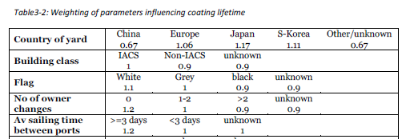
Figure 9 Citation from D 5.1, table 3-2: Weighting of parameters influencing coating lifetime (first 5 rows)
From both of these statements, we can conclude, that the correct value for "class" cannot be read directly from ONE existing database. Even the IACS membership status of the ships classification society is no datum, which is directly available from one machine readable data source. In fact, it is a verbal definition of how to integrate data from not yet named data sources in order to lookup the desired value from D5.1's table 3-2.
Table 3-2 of D 5.1 is an example of expert judgement quantification values for BN nodes. This data has to be part of the data integration scenario. It is assumed that this kind of data will be stored in one Safepec database.
The types of leaf-models used in WP 5 (so far : September 2016) are
- CPT of a BN node
- CPD of a BN node
- Probabilities of events in a fault tree nodes
- Response surface equations
If the evaluation of a leaf-model depends on some ship data -- which is usually true, then it is the common case that the kind of ship data is in fact some defined aggregate such as a grouping or category as just illustrated by the example of "class" in the corrosion-cause model. Thus, the task of WP 2 is to encode the data integration definitions such, that they can be queried from a data integration module. This holds for all types of leaf-models inside the risk assessment module. It is no restriction to the general goal of WP 2 to focus on BN nodes as a representative for all leaf-model types.
The DIM has to be setup on an information structure representing the data integration definitions (see Figure 8). As the DIM will be able to identify all data integration definitions that resolve dependencies of a leaf-model, the respective leaf-models and dependencies have to be setup as well. This approach can be easily taken to higher levels of the model hierarchy.
Referring to the sample dependency hierarchy of Figure 8, the expected response behaviour of the DIM is something like:
Query quantification resolution for class get quantification for class
Query quantification resolution for cargo get quantifications for class, ship_type
Query quantification resolution for corrosion get quantifications for detentions, deficiencies, year_built, yard, flag, owner, class, ship_type
As can be seen from the simple exercise above, the labelling – or better identifications – of the nodes in the risk model dependency hierarchy is an important part of the DIM specification. The node identifications have to be inline and agreed with WP 4 and WP 5 and the risk module implementation. For this reason, a questionnaire has been developed in the scope of WP 2 to collect the respective data from WP 4 and WP 5. The details of this questionnaire and the results will be reported in D 2.2.

Technical Requirements from Implementation
The final deliverable of WP 2 will be a prototype implementation of the data integration module serving the required data to run the risk assessment evaluation by the risk module.
It is the general idea of WP 2 to use an OWL ontology for the data integration task. Since Task 2.3 will provide a prototype implementation of the DIM, it is necessary to consider boundary conditions arising from this side as early as possible and to design the ontology with the focus on the expected functionality of the DIM.
In the following, it will be roughly outlined how the implementation of this ontology based data integration is planned and which implications arise to the development of the ontology itself.
Still focussing on the runtime use case, the DIM will provide the values of all data integration definitions for a given vessel and sub-model. A rough building block view of the DIM neighbourhood is given in Figure 10.
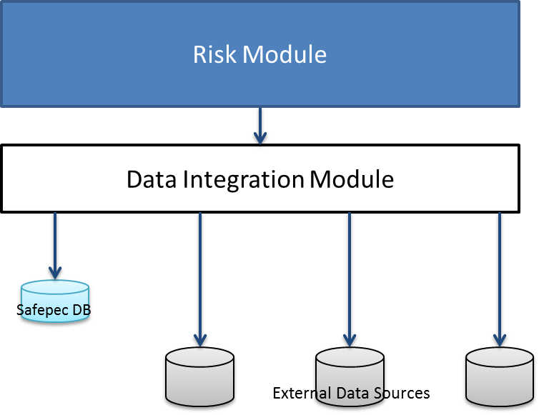
Figure 10 Rough building block view of the DIM neighbourhood inside a possible Safepec software application

Calling Interface to DIM
At the interface between DIM and its caller (the Risk Module), an interface method similar to
[{submodel_id: string, key: string, value: double}]
GetValuesFor( vessel_id as string,
submodel_id as string )
Statement 1 Pseudo-code of interface method to query quantification for some sub-model valid in the scope of a certain vessel.
has to be provided to fulfil the given goal. Again, the example of the corrosion-cause model is taken for illustration. In order to quantify the corrosion-cause sub-model (refer to Figure 7, Figure 11) for a vessel identified by its IMO number (e.g. "9173317"), the call to the DIM would look similar to
GetValuesFor( "9173317", "corrosion-cause" )
Statement 2 Pseudo-code to call interface method of Statement 1 for vessel IMO number “9173317” and sub-model identification “corrosion-cause”
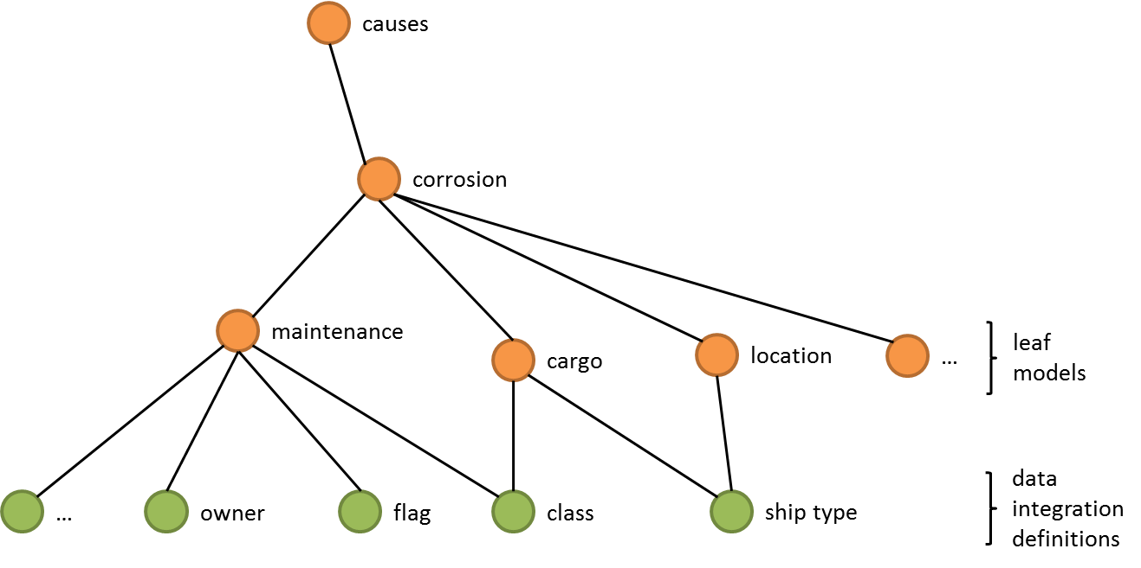
Figure 11 Simplified sub-model hierarchy as applied in the sample statements, refer to Figure 8
And the expected result set would look similar to
[
{submodel_id: "corrosion-cause/detentions",
key: "f_corrosion", value: 0.78},
{submodel_id: "corrosion-cause/deficiencies",
key: "f_corrosion", value: 0.9},
{submodel_id: "corrosion-cause/year_built",
key: "f_corrosion", value: 0.35},
{submodel_id: "corrosion-cause/yard",
key: "f_corrosion", value: 0.9},
{submodel_id: "corrosion-cause/flag",
key: "f_corrosion", value: 1.0},
{submodel_id: "corrosion-cause/owner",
key: "f_corrosion", value: -4.0},
{submodel_id: "corrosion-cause/class",
key: "f_corrosion", value: 3.8},
{submodel_id: "corrosion-cause/ship_type",
key: "f_corrosion", value: 1.0}
]
Statement 3 Pseudo-code of return value for Statement 2
Please note that the actual values and identifiers of the above statements are only samples.
The ontology inside DIM considers the internal hierarchy of the sub-models. Thus, the following call will also lead to a valid result:
GetValuesFor( "9173317", "corrosion-cause.cargo" )
Statement 4 Pseudo-code to call interface method of Statement 1 for vessel IMO number “9173317” and sub-model identification “corrosion-cause.cargo”
The expected result set is:
[
{submodel_id: "corrosion-cause/class",
key: "f_corrosion", value: 3.8},
{submodel_id: "corrosion-cause/ship_type",
key: "f_corrosion", value: 1.0}
]
Statement 5 Pseudo-code of return value for Statement 4

Interface to data sources
To understand the interface between the DIM and the data sources, we have to consider that the data integration is done by an OWL ontology according to the description of work (ontology-based data access, OBDA). An OWL ontology acts on RDF data. But the data sources to be connected are relational, i.e. with a table structure.
Converting the complete set of relational data to an RDF representation, storing it in some RDF store and keeping it up-to-date with respect to changes of the original data sources would require too much resource in terms of time and storage capacity. Furthermore, it would be hard to maintain (update).
“A key aspect of OBDA is that data is obtained from one or more legacy systems, e.g., RDBMSs, XML systems, etc. To use this data in a Semantic Web application a user needs to perform an ETL process, i.e., (E)xtract the data from the sources, (T)ransform it into an OWL ABox (or as RDF triples), and (L)oad it into a query answering system (i.e., a reasoner or triple store). This practice has several drawbacks. First, it puts the burden of ETL on the client’s application code, which increases software complexity of the application, and hence, the cost of development and maintenance. In addition, this generates duplicated data that consumes resources and introduces the problem that, in the event of an update on the data source(s), the system becomes out of synch. But more importantly, the fact that the query answering system is aware neither of the provenance of the data, nor of the way in which the data was extracted from the sources is an important missed opportunity for optimization during inference and/or query answering.” Refer to (Mariano Rodríguez-Muro, 2012).
An alternative to the ETL process is the on-the-fly perfect rewriting of SPARQL queries to SQL queries and evaluating them on the online relational databases, see Figure 12. This approach is developed and implemented as -ontop- framework.
“The -ontop- framework is developed in the Knowledge Representation meets Databases (KRDB) research group at the Free University of Bozen Bolzano (FUB). Its development started in the context of the European FET project Thinking ONtologiES (TONES) project, then continued independently at FUB and currently, it is being extended in the context of Optique project, a large Integrated Project (IP) financed by the EU’s Seventh Framework Program (FP7) in which Ontop is a core component.”
Refer to <http://ontop.inf.unibz.it/about-us/>
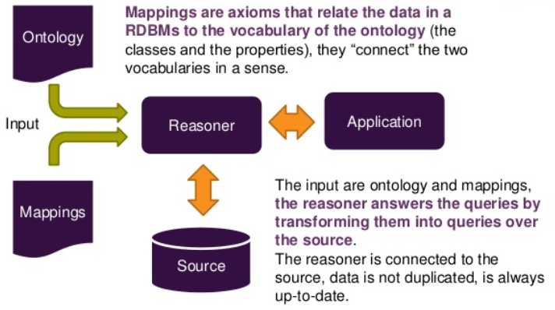
Figure 12 On-the-fly approach to OBDA (Muro, 2013)
The implementation of DIM by task 2.3 will be based on -ontop-. The reasoner component inside -ontop- is named Quest. It is able to answer SPARQL 1.0 queries and supports OWL 2 QL inference.
To allow for a proper implementation of DIM it is important to reduce the OWL feature set used for the ontology to OWL 2 QL, refer to (W3C, 2012).

Internal View
Figure 11 provides an overview of the internal components and their interactions of the DIM. This helps to provide an understanding of the further approach in designing the ontology and to outline how to finally realize the data integration by means of this ontology. The details of the implementation will be outlined in task 2.3. Figure 11 is only used to identify the core components of DIM relevant for the design of the ontology.
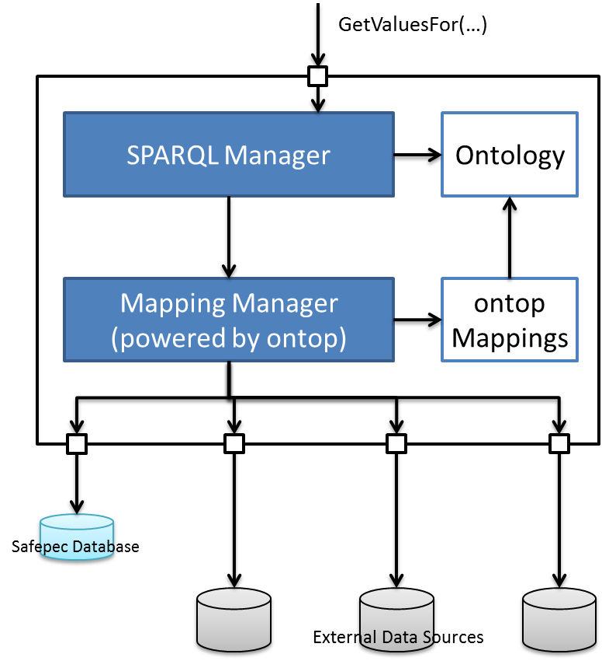
Figure 13 Component view of DIM
The responsibilities of the components shown in Figure 11 are as follows:
SPARQL Manager: The SPARQL Manager handles all external calls. Based on the Ontology, it prepares a valid SPARQL query and passes it to the Mapping Manager. The returned result set also forms the result set for the call and is transformed to the expected format, e.g. JSON.
Ontology: The ontology contains the data integration definitions, refer to section ‎3. I.e., the Ontology stores the knowledge by which it is possible to resolve the submodel_id (refer to Statement 1) to the data integration definitions the sub-model depends on. Additionally, the Ontology encodes by which aggregation of vessel data the correct values can be found at the SAFEPEC database.
Mapping Manager: The Mapping Manager encapsulates -ontop- and is responsible for executing the SQL queries.
-ontop- Mappings: The -ontop- mappings define how the virtual ABox is constructed from the results of the SQL queries.
Thus, the setup of the data integration definitions consists of three elements:
- The SPARQL queries to be prepared by the SPARQL Manager.
- The Ontology consisting of OWL 2 QL class statements (TBox).
- The -ontop- Mappings establishing the aggregated vessel data as required by the data integration definition and the tables from the Safepec database.

Designing the ontology
With respect to the runtime use case, this chapter will show, how the ontology is actually constructed with the purpose of allowing general SPARQL queries as core of the implementation of the DIM's SPARQL Manager component, refer to section ‎6 Figure 10.
Reflecting on the aim for DIM as stated in section ‎3, the Safepec ontology is designed with respect to ensuring the consistency of the result data and hiding the complexity of the data sources from the users. The up-to-datedness of the results is ensured by using a query re-writing strategy and thus being able to query directly on the live data sources (as far as this is applicable for the Safepec project). The design of the ontology is affected by the use of -ontop- (as the query re-writing component) which restricts the applicable OWL set to OWL 2 QL.

Notation
The terminology for describing the Safepec ontology is based on Matthew Horridge's introduction to building OWL ontologies (Horridge, 2011).

For illustration of some facts, this chapter will use screenshots from the ontology development tool Protégé. The visual notation of classes and individuals used by Protégé can be seen from Figure 12 below. Classes are shown with a yellow circle while individuals are shown by a violet diamond symbol.

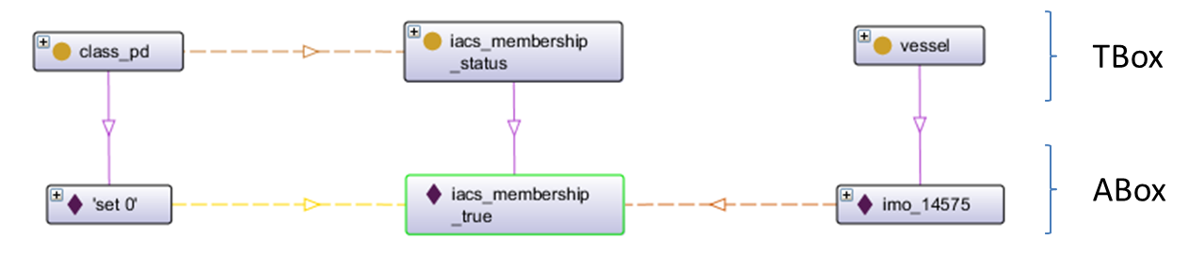
Figure 14 Introduction to OntoGraf visualization provided by Protégé
Object property assertions between individuals and object property restrictions between classes are shown as dashed lines. Object properties defined by OWL such as "has individual" or "has subclass" are shown as solid lines. The orientation of the object properties is indicated by an arrowhead in the centre of the line.

Ontology Design Principles
With designing the Safepec ontology some design principles have been followed in order to achieve the desired result.

Link to other ontologies
The ontology will be prepared in a Safepec namespace only referring to established RDF and OWL standards or widely accepted ontologies like FOAF or SKOS. This way it is independent from developments of other ontologies.
To provide the link to other ontologies (like BFO, IAO or domain specific ontologies like e-Navigation, e-Maritime, e-Compliance) and thus to add the knowledge encapsulated by the Safepec ontology to the semantic world, there are additional RDF statements described by chapter … These RDF statements introduce SKOS or OWL subClass statements to materialize the link to selected public ontologies.

OWL 2 QL
The ontology is designed to solve a data integration problem. The implementation will be based on ontop. For allowing ontop and thus the planned implementation of the data integration module to work properly, the ontology has to be prepared applying the OWL 2 QL set. Thus, some OWL constructs cannot be used by the Safepec ontology such as universal quantifications or transitive object properties.

Resolve database records to domain concepts by -ontop- mappings
The concepts, which are actually introduced by the domain, are usually aggregates of the actual data from the data sources to be integrated. A definition for such aggregate data which is based on data actually available from data sources is an important part of the complexity of the domain. To handle this complexity efficiently and centrally, the aggregate definitions will be formulated as -ontop- mappings.

Ensure consistency
In order to ensure consistency of the data provided by the data integration module, the ontology is designed such, that the SPARQL queries can be constructed around class restrictions (TBox assertions). Since the ABox (see Figure 12) only virtually exists by query re-writing at query runtime, relying on individual assertions for the SPARQL queries would imply to ensure consistency by the -ontop- mappings. By making it a design principle to use the class restrictions to assert, that the individuals related by an object property assertion can be consistently classified, the responsibility for this consistency is clearly located inside the OWL ontology. (Horridge, 2011)

Competency Questions
“One of the ways to determine the scope of the ontology is to sketch a list of questions that a knowledge base based on the ontology should be able to answer, competency questions (M. Grunniger, 1995). These questions will serve as the litmus test later: Does the ontology contain enough information to answer these types of questions? Do the answers require a particular level of detail or representation of a particular area? These competency questions are just a sketch and do not need to be exhaustive.” Refer to (Natalya F. Noy, 2002)

The overall competency question to the Safepec domain for the runtime use case is:
Get the result set of parameter label and value for a given vessel and data integration definition class!
As it is difficult to answer such a complex question in one step, some partial questions are derived from this overall goal.
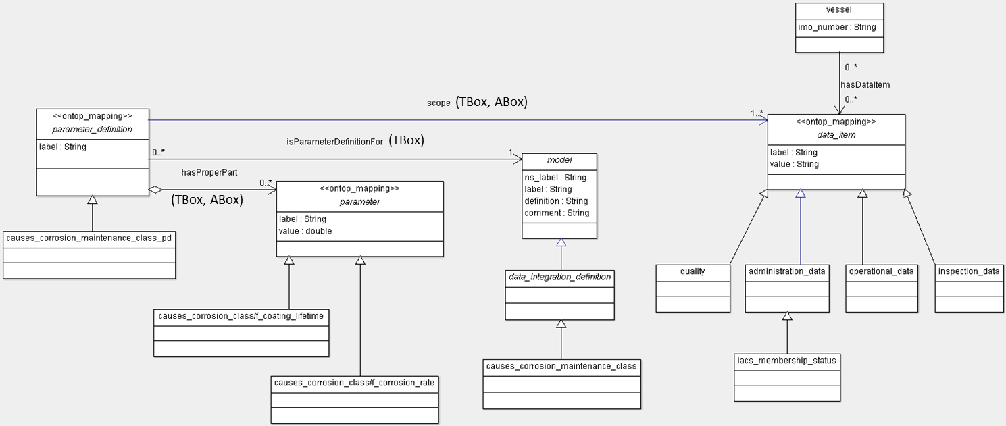
Figure 15 Basic UML class diagram of the Safepec data integration data model
The UML class diagram in Figure 13 introduces the terms now used to formulate the competency questions in a more formal manner by their inheritance hierarchy and named relationships.
The terms referring to some concept of Figure 13 (or the Safepec ontology later on) will be printed mono-spaced for better identification.
CQ-a: Which data_integration_definitions are required to resolve all dependencies of a given sub-model?
CQ-b: Which parameter_definitions (class) exist for the given data_integration_definition (class)?
CQ-c Which data_items (class) are in the scope of these parameter_definitions (class)?
CQ-d Which data_item (indiv.) value exists for the data_item (class) for the given vessel (indiv.)?
CQ-e Which parameter_definitions (indiv.) are individuals to the above parameter_definition (class) sub-class and have a vessel's data_item (indiv.) as their scope?
CQ-f Which parameters (indiv.) by label and value are proper part of this parameter_defintion (indiv.)?
As can be seen from this competency questions, the overall ontology acts in TBox (class assertions) and ABox (individual assertions). Only the TBox will be defined by this report. For the purpose of testing the ontology, some sample individuals are created manually.

Ontology Explained
Figure 13 only shows the basic data model underlying the Safepec ontology to introduce the concepts and their relationships. By an OWL ontology, the classes of a UML class diagram are represented as OWL classes. The relationships of Figure 13 can be represented as domain and range of OWL object properties. For references between UML class diagrams and OWL ontologies, see (Qiang Tong, 2014), (CIMTool).
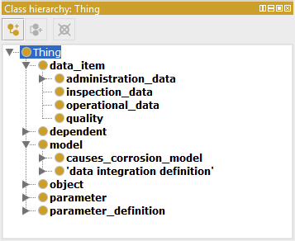
Figure 16 Class hierarchy of Safepec ontology as presented by Protégé
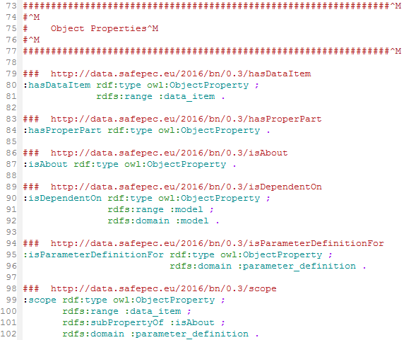
Figure 17 Object property definitions of Safepec ontology in turtle syntax.
In order to allow for proper answering of the competency questions above, the Safepec ontology has additional object property restrictions, which will be explained in the following sections.
The following sections will explain the different concepts (see Figure 14) and their relationships (see Figure 15) in detail.

model
The purpose of the model class hierarchy is to establish unique resource identifiers (URI) to each sub-model of the risk models which may be addressed as input parameter to the DIM interface method “GetValuesFor”, refer to section ‎6.1.
The model sub-classes are arranged into a sub-class hierarchy for better overview and maintainability, see Figure 16.

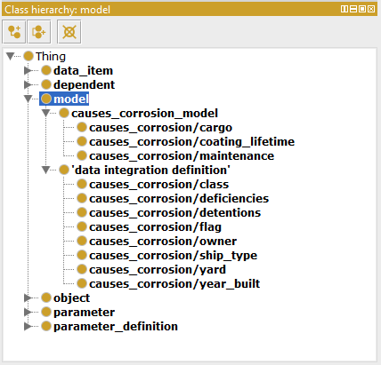
Figure 18 Class hierarchy of model.
The data_integration_definition class represents the parent class to all models that are data integration definitions according to Figure 8.
The parent concept model itself is defined by references to more formal ontologies, refer to section … below.

dependent
As can be seen from Figure 8, the risk assessment model and its sub-models establish an internal dependency hierarchy. These dependencies (see Figure 17) are added as sub-class of dependent to the ontology. Doing so, the SPARQL query to competency question 1 will be able to traverse the dependency hierarchy of each sub-model down to its data_integration_definitions.
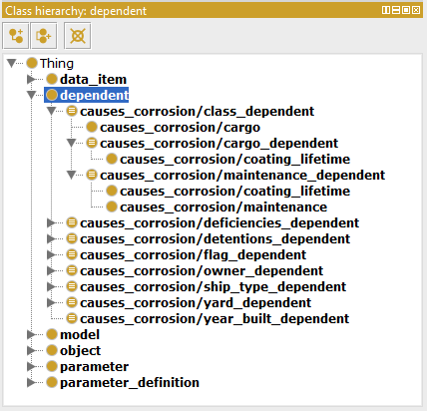
Figure 19 Class hierarchy of dependent
A sub-class of dependent is equivalent to something that isDependentOn a sub-model. Thus, all dependents are provided as defined classes, expressed by OWL equivalentClass.
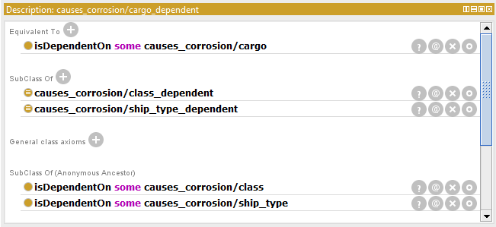
Figure 20 Definition of causes_corrosion/cargo_dependent as visualized by Protégé
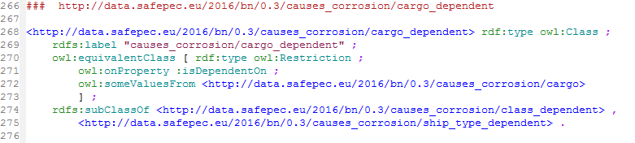
Figure 21 Definition of causes_corrosion/cargo_dependent in turtle notation
Figure 18 illustrates the causes_corrosion/cargo_dependent, which represents the dependencies of the cargo node of the corrosion cause model shown in Figure 7. The causes_corrosion/cargo dependent is defined as equivalent to something that isDependentOn some causes_corrosion/cargo sub-model, see OWL equivalentClass statement in Figure 19. Additionally, it is described as sub-class of causes_corrosion/class_dependent and causes_corrosion/ship_type_dependent. As can be seen from Figure 20, this automatically resolves to further isDependentOn statements concerning causes_corrosion/class and causes_corrosion/ship_type as anonymous ancestors.
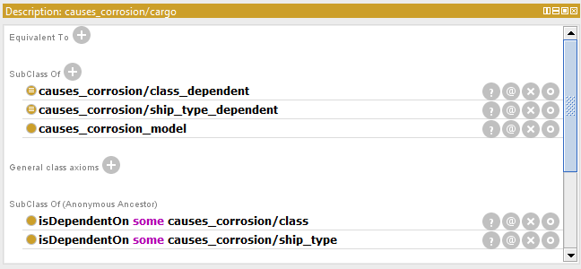
Figure 22 Definition of causes_corrosion/cargo as visualized by Protégé
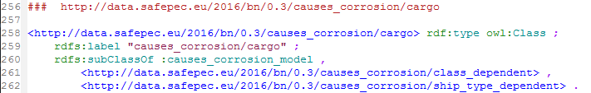
Figure 23 Definition of causes_corrosion/cargo in turtle notation
This example seems to be quite elaborate for the achieved result. But looking at a sub-model with a deeper hierarchy of dependencies (Figure 20, Figure 21), this approach automatically resolves the complete list of dependencies as "anonymous ancestors". And this is what is actually needed, to provide a general SPARQL query to competency question 1.
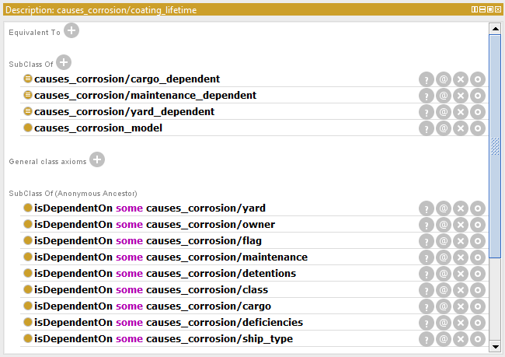
Figure 24 Definition of causes_corrosion/coating_lifetime as visualized by Protégé
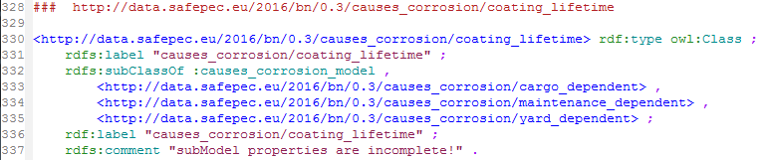
Figure 25 Definition of causes_corrosion/cargo in turtle notation

data_item
A data_item is the concept that generalizes all data known of an object and thus of a vessel. By means of the data_item it is possible to formulate SPARQL queries, which resolve the access to any data known of a vessel in a general way. This ability is crucial for dealing with the competency questions 3 and 4.
The data_item of a vessel can represent a complex and/or aggregated data item, i.e., it has not to be directly available as a column from a relational data source. In fact, the purpose of the data_item is to provide an OWL class for each concept used by the risk assessment models to run a look-up to a table from the Safepec database (refer to Figure 9). This implies that there is a sub-class of data_item for every such concept introduced by the risk assessment model. A sample fragment of this class hierarchy can be seen in Figure 24. These sub-classes allow to classifying each data_item individual. This is important to ensure the consistency of the data on the class level.
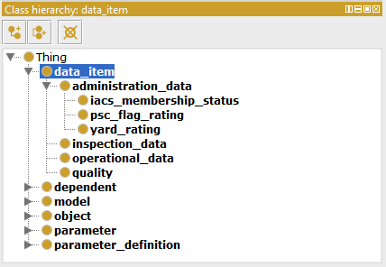
Figure 26 Class hierarchy of data_item
The individuals of the data_items are created from complex -ontop- mappings. These mappings have to resolve the complexity which is hidden in the fact that the database information is not at all represented by data, which is directly available from data sources. Since it is the aim of Safepec's data integration approach to leave the data in its relational tables and only act upon a virtual ABox and SQL is proven to be fast in relational data access, it is straight forward to place the resolution of the complexity inside the ontop mapping statements.
The different types of (-ontop-) mappings, which are necessary to describe the complete scope of data integration definitions arising from the risk assessment models, will be reported by D2.2. An example for mapping a string to an enumeration will be illustrated further down this chapter.

parameter
The parameter as used by this Safepec ontology can be interpreted as a data cell in a relational table as shown in Figure 25.
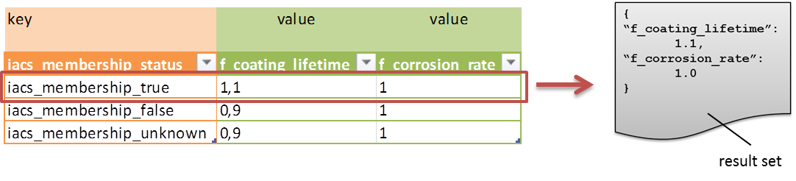
Figure 27 Sample table from Safepec database representing the data necessary to quantify the class node of Figure 7
Applying this analogy, the individual cell or parameter (apart from its URI) needs to be described by
- a row: the individual parameter_definition which the parameter is a part of
- a column: the sub-class of parameter by which the individual can be classified
- a value: parameter data property assertion hasValue
Figure 26 below illustrates the OWL representation of parameter and data_item also with respect to the parameter_definition introduced in section ‎7.4.5.
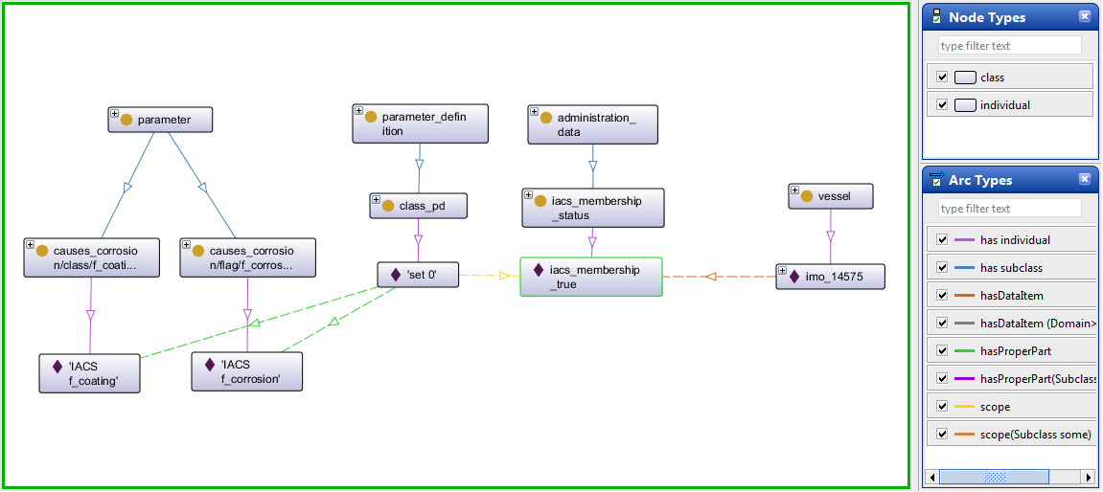
Figure 28 Screenshot on sample individuals from Protégé: parameter, data_item, parameter_definition representing one row of the table in Figure 25
The purpose of parameter for the runtime use case is to populate the result set, see Figure 25. Since the result set to a query consists of a set of key/value pairs, a label acting as the key has to be uniquely assigned to every parameter individual. In the table cell analogy, this key is represented by the cell's column header.
Assigning this label can either be achieved by a label annotation property to each individual parameter. In an -ontop- scenario, this implies to define the correct labelling (i.e., the correct keys) by the -ontop- mappings. Alternatively, the labels can be stored on the class level as a label to some parameter sub-class. For ensuring consistency, the latter approach seems to be more feasible to the author. Doing so requires an additional disjoint class statement to the sub-classes of parameter. Otherwise, due to the open world, the unambiguousness of the parameters classification cannot be guaranteed.
In addition to getting the labels for the result set from statements asserted in the TBox, the benefit of introducing a sub-class hierarchy to parameter is again the ability to check the individuals for consistency.
Since the parameters known so far from D5.1, D5.2 are probabilities or quantification factors without unit, a data field for the unit has not yet been introduced to the ontology.
The row index for a parameter is provided by the parameter_definition, which it is part of, see section ‎7.4.5 below.

parameter_definition
As can be seen from figure 1, the parameter_definition class is the one that links everything together. A parameter_definition needs to express, that it applies its definition to some Thing. In Figure 15, this is represented by the domain of the isParameterDefinitionFor object property. The range is left blank in order to allow this object property also to relate parameter_definitions to other kinds of Things.
The actual meaning of the domain statement for the isParameterDefinitionFor is that everything that occurs as a subject to a RDF statement around isParameterDefinitionFor is sub-class of parameter_definition. If this is not asserted explicitly by the ontology, this statement can be inferred by an OWL reasoner. Nothing like this can be inferred for the object in such a RDF statement, because range is left blank. I.e., the ontology is open to allow this way of dealing with parameter_definitions for any other kind of Thing apart from model.
The object property scope is the main representation of the link between the world of the risk models and the actual data_items of a physical object, i.e. the vessel. It is thus made explicit in domain and range, that scope only appears in RDF statements of parameter_definition and data_item. Again, if individuals appear in RDF statements using scope as its predicate, the type of class for subject and object of this RDF statement can be inferred. On the other hand, if there are RDF statements with scope about individuals which cannot be parameter_definition or data_item, respectively, the reasoning will lead to an inconsistent ontology. This is to avoid, that there is data linked together by the object property scope, which cannot be used in meaningful and true RDF statements.
Finally, there is another object property definition for parameter_definition which is called hasProperPart. In the class diagram of Figure 13, it is shown as an aggregation to parameter_definition. The purpose of hasProperPart is to relate the individuals of the label/value pairs in a standard way to each parameter_definition.
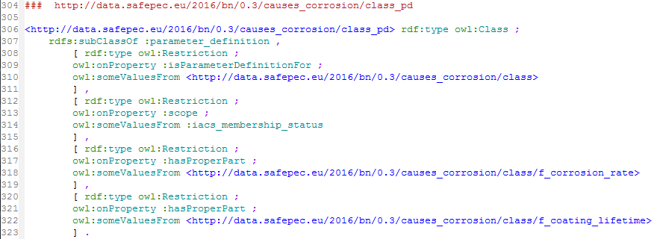
Figure 29 Definition of the parameter_defintion sub-class causes_corrosion/class_pd in turtle notation
Actually, each parameter_definition can be understood as an entry to a dynamically created result set for a given (sub-)model defined by the Safepec ontology and applying to a certain scope. A visual representation of a parameter_definition is provided by Figure 26.

Testing the ontology
As opposed to a data model (as represented by the UML class diagram in Figure 13 for instance) an ontology can be applied. Applying an ontology can either mean to actually classify some existing data. But it also means to return data which has been queried. Of course, the first case is usually included in the latter.
To apply the Safepec ontology, the competency questions (refer to section ‎7.3) formulated as a requirement to the ontology design shall be used to test it.
This section starts with introducing some sample data. Then, each competency question will be formulated as a SPARQL query and presented together with the result set. Finally, the SPARQL query that answers the runtime use case method calls to the DIM will be constructed out of the competency SPARQL's.

Sample individuals
The sample case has been created based on D5.1 figure 3-4. From the corrosion cause model, three "sub-model" nodes have been picked. They are
- maintenance
- cargo
- coating_lifetime
For the coating_liftetime node, only the dependencies to maintenance, cargo and yard have been modelled.
To state the required class restrictions for the consistency check, the respective sub-classes to model, parameter and data_item have been added, see Figure 28 below.
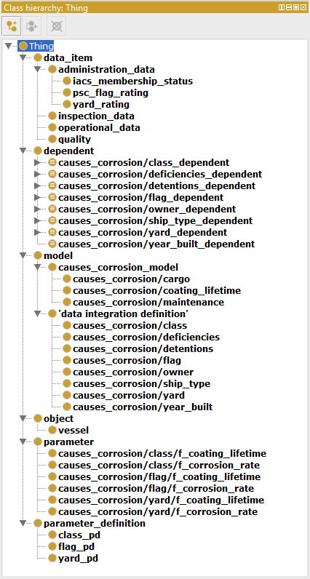
Figure 30 Overview on classes of sample individuals
The object property restrictions describing the classes are part of the parameter_definition sub-classes. An example can be seen from Figure 27.
For testing purposes, the required individuals have been added manually. In a future scenario of the data integration module, they will be created virtually at runtime of the queries (refer to –onto-). The sample of a parameter_definition individual "set 2" with a scope from iacs_membership_status individual, i.e. iacs_membership_true, is shown as screenshot from Protégé in Figure 26.
The information to which kind of data_integration_definition the parameter_definition individual "set 2" applies is represented on the class level, only. For this sample, causes-corrosion/class-pd resolves to a data_integration_definition called causes-corrosion/class.
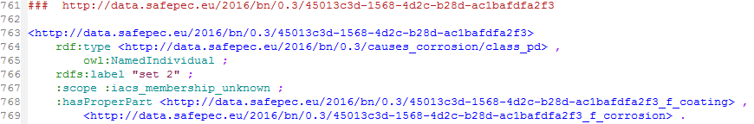
Figure 31 Sample individual “set 2”, turtle notation
The sample data for data_integration_definitions causes_corrosion/flag and causes_corrosion/yard have been constructed in the same way. These two additional data sets have been added as a negative sample to ensure by the tests, that only valid data is returned by the SPARQL's.

SPARQL queries
In the following, the SPARQL code to the competency questions discussed in section ‎7.3 is presented. Figure 30 shows the prefix definitions which apply to all SPARQL statements.
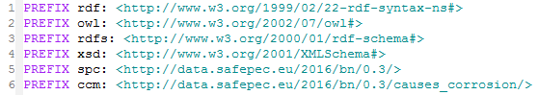
Figure 32 Prefix definitions for the SPARQL queries

Competency Question CQ-a
The purpose of CQ-a is to identify the data_integration_definition classes, which are necessary to resolve the complete dependencies of a given sub-model. The code of the SPARQL query is shown in Figure 31 .
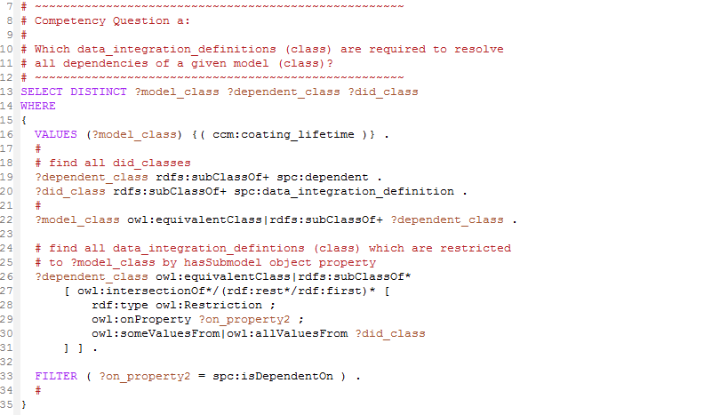
Figure 33 SPARQL code to CQ-a
The input value to the SPARQL query is defined in line 16. By the statements in line 19 - 20 all sub-classes of dependent and data_integration_definition are bound to variables. With line 22, those ?dependent_class candidates are selected, which are sub-class to the given ?model_class. The statements of lines 26 - 33 identify those candidates for ?did_class, which have an object property restriction with along isDependentOn with the identified ?dependent_class.
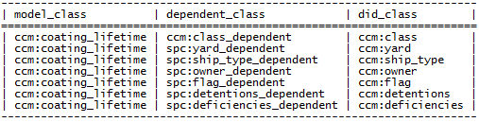
Figure 34 Result set to CQ-a
Figure 32 shows the result set for the above SPARQL query on the Safepec ontology with sample individuals as described in section ‎7.5.1. By means of the dependents, the expected data_integration_definitions can be identified. As can be seen from Figure 7 ccm:year_built is not in the dependency hierarchy of the input value ccm:coating_lifetime. Thus, it is not part of the result set.

Competency Question CQ-b
The purpose of CQ-b is to identify the parameter_definition class, which applies to a given data_integration_definition class via a isParameterDefinitionFor object property restriction. The code of the SPARQL query is shown in Figure 33.
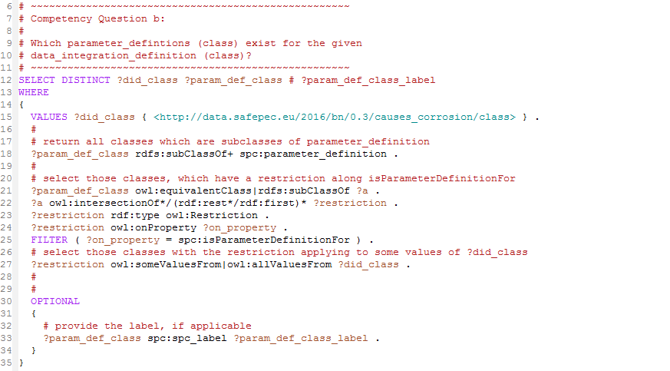
Figure 35 SPARQL code to CQ-b
The input value to the SPARQL query is defined in line 15. By the statement in line 18 all sub-classes in the hierarchy of parameter_definition are bound to the variable ?param_def_class. The statements of lines 21 - 27 identify those candidates for ?param_def_class, which have an object property restriction along isParameterDefintionFor (line 25) to some or all values from the input value (line 27).
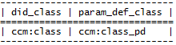
Figure 36 Result set to CQ-b
Figure 34 shows the result set for the above SPARQL query on the Safepec ontology with sample individuals as described in section ‎7.5.1. As expected, for the data_integration_definition "causes-corrosion/class" the parameter_definition class "causes_corrosion/class_pd" applies.

Competency Question CQ-c
The purpose of CQ-c is to identify the data_item classes, which describe the scope of a paramter_definition class via a scope object property restriction. The code of the SPARQL query is shown in Figure 35.
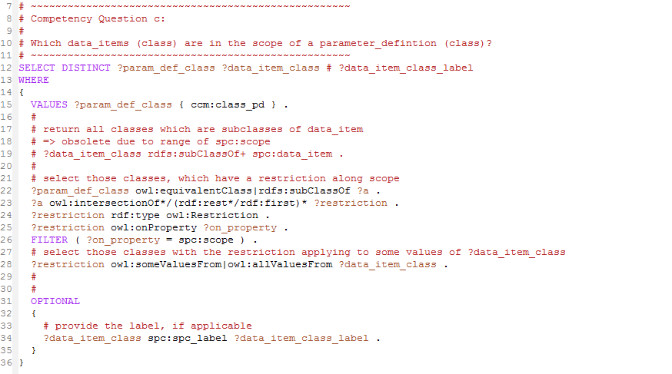
Figure 37 SPARQL code to CQ-c
The input value to the SPARQL query is the parameter_definition sub-class "causes-corrosion/class_pd" as defined in line 15. The statements of lines 22 - 28 identify those candidates for ?data_item_class (line 28), which have an object property restriction along scope (line 26) originating in ?param_def_class (line 22).
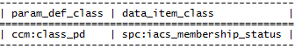
Figure 38 Result set to CQ-c
Figure 36 shows the result set for the above SPARQL query on the Safepec ontology with sample individuals as described in section ‎7.5.1. As expected, for the parameter_definition "causes-corrosion/class_pd" the data_item class "iacs_membership_status" is forming the scope.

Competency Question CQ-d
The purpose of CQ-d is to identify the data_item individual(s) of a given data_item class for a given vessel individual. The code of the SPARQL query is shown in Figure 37.
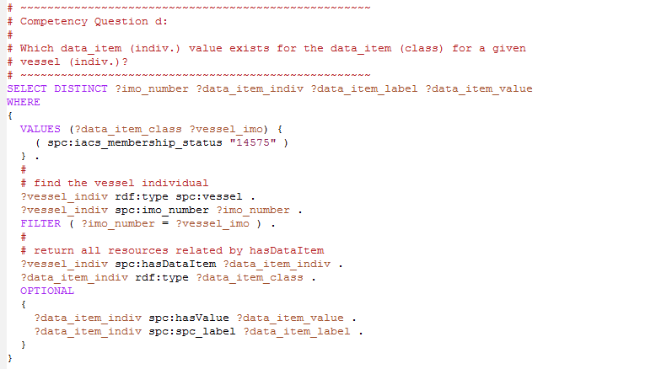
Figure 39 SPARQL code to CQ-d
The input values to the SPARQL query are the data_item sub-class "iacs_membership_status" and the vessel IMO number "14575" as defined in lines 15 - 16. The statements of lines 20 - 22 identify the vessel with the given IMO number. Lines 25 - 26 return the data_item individuals related to this vessel individual by the object property assertion hasDataItem, which are of type ?data_item_class. If available, the result set is completed by label and value of the data_item individual.
Figure 40 Result set to CQ-d
Figure 38 shows the result set for the above SPARQL query on the Safepec ontology with sample individuals as described in section ‎7.5.1. The individual of the data_item iacs_class_membership asserted to the vessel with IMO equal to "14575" is "iacs_membership_true".

Competency Question CQ-e
The purpose of CQ-e is to identify the parameter_definition individuals of a given parameter_definition sub-class, which have object property assertions along scope to a data_item individual of a given vessel. To ensure the consistency with the ontology, it is checked, if the data_item class is valid in the scope restriction of the parameter_definition sub-class.
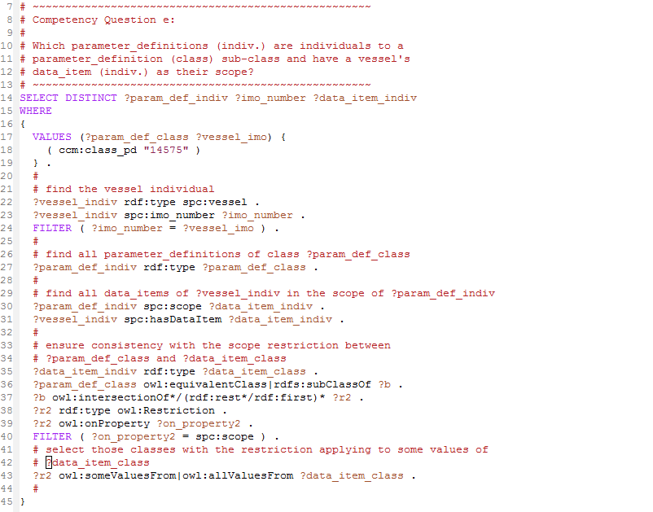
Figure 41 SPARQL code to CQ-e
The input values to the SPARQL query are the parameter_definition sub-class "causes_corrosion/class_pd" and the vessel IMO number "14575" as defined in lines 17 - 19. The statements of lines 22 - 24 identify the vessel with the given IMO number. Lines 30 - 31 return the data_item individuals related to this vessel individual by the object property assertion hasDataItem and are in the scope of the parameter_definition_individual at the same time.
Lines 35 - 43 ensure the consistency of the data_item individuals class with respect to the object property restriction along scope stated for the parameter_definitions class.
Figure 42 Result set to CQ-e
Figure 40 shows the result set for the above SPARQL query on the Safepec ontology with sample individuals as described in section ‎7.5.1. The individual parameter_definition can be identified. The data_item individual that builds the bridge between the scope of the paramter_definition individual and the vessel individual is "iacs_membership_true".

Competency Question CQ-f
The purpose of CQ-f is to provide the parameter individuals by label and value of a given parameter_definition class. The result of this query corresponds to a parameter table as defined by Figure 41.
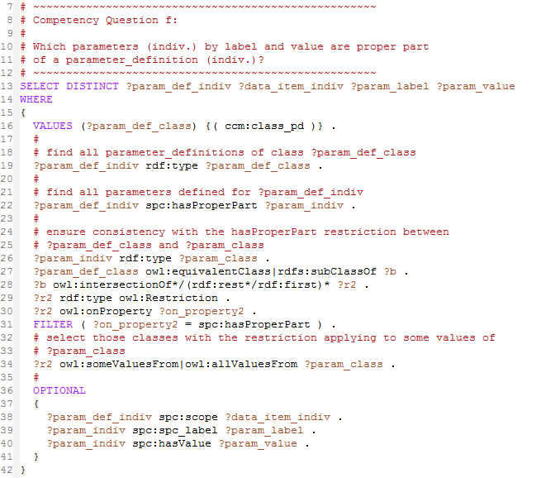
Figure 43 SPARQL code to CQ-f
The input values to the SPARQL query is the parameter_definition sub-class "causes_corrosion/yard_pd" given in line 16. With line 19 all individuals of this class are identified. And line 22 gives the related parameter individuals.
The code block of lines 26 - 34 is used to ensure the consistency of the paramters class according to the restrictions stated in the ontology for the given parameter_definition.
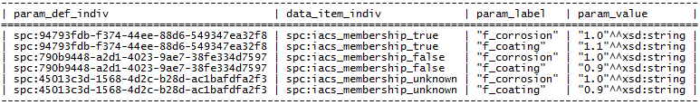
Figure 44 Result set to CQ-f
Figure 42 shows the result set for the above SPARQL query on the Safepec ontology with sample individuals as described in section ‎7.5.1. The returned …

Runtime SPARQL
The purpose of the runtime SPARQL query is to provide a valid result set to the data integration module interface method "GetValuesFor()", refer to section ‎6.1.
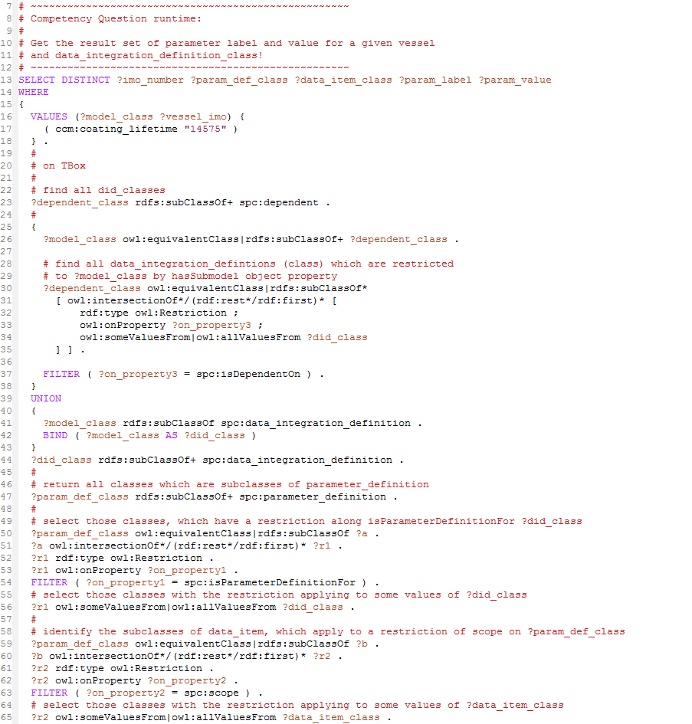
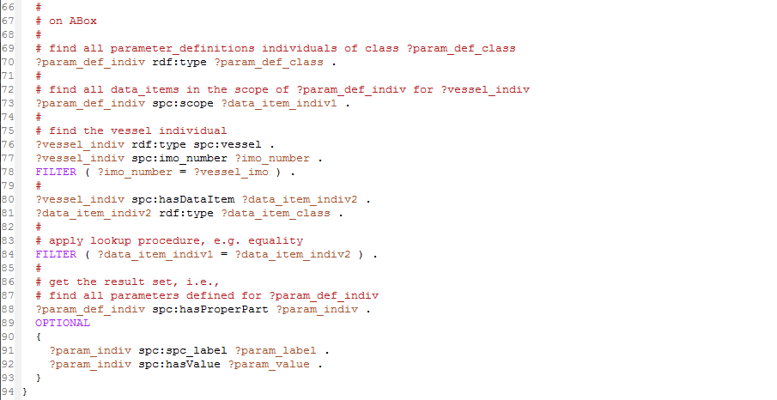
Figure 45 SPARQL code to runtime SPARQL
The input values to the SPARQL query are a valid model sub-class URI and an IMO number to identify the target vessel. The code of this SPARQL query is basically assembled from the competency queries a - f above.
The query is organized in a first block, which acts on the Tbox (class restrictions), and a second block, which acts on the ABox (individual assertions).
By the lines 25 - 44, the data_integration_definition classes are identified, which resolve the dependencies of the input sub-model. It is constructed as a UNION of two cases. The first case applies to sub-model which are no data_integration_definitions. The second case applies to those which are themselves data_integration_definitions.
With lines 47 - 56, the parameter_definition classes are selected, which are related to the above data_integration_definitions. For each of the parameter_definitions, the data_item classes to which the scope object property is restricted are selected with lines 59 - 65.
After having all relevant classes identified, the corresponding individuals are selected. With moving the actual lookup operation, i.e. how the match between the parameter_definition scope and the vessels data_item is established, to a FILTER statement, allows for later change to matching operators other than "equal".
Figure 46 Result set to runtime SPARQL for ?model_class = causes_corrosion/class
The SPARQL query in Figure 43 is executed with "causes_corrosion/class" as sub-model. The result set is shown in Figure 44. It consists of the parameters stored for "causes_corrosion/class" in the sample set.
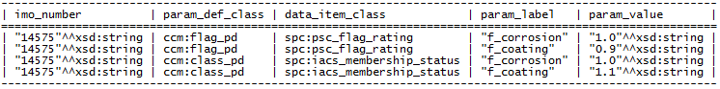
Figure 47 Result set to runtime SPARQL for ?model_class = causes_corrosion/coating_lifetime
Executing the runtime query in Figure 43 with "causes_corrosion/coating_lifetime" returns the result set shown in Figure 45. Currently, only parameters for psc_flag_rating and iacs_membership_status are asserted in the sample data. It can be seen, that "causes_corrosion/coating_lifetime" is expanded to data_integration_definition classes class and flag.

Summary
The Safepec ontology for the runtime use case, which has been introduced in this chapter, allows for a very lightweight implementation of the SPARQL Manager component, see Figure 11. The SPARQL queries for such an implementation have been presented and tested along some sample individuals designed to reflect the corrosion cause model, refer to D5.1.
The SPARQL queries have been prepared such that they assert the consistency of the returned data according to the conditions stored with the ontology.
Adding further sub-models or data integration definitions to the data integration module requires adding further RDF statements to the TBox of the ontology for
- sub-class to model to assign a unique identifier , that can be used with the data integration module to query
- state the dependencies of the new sub-model
- prepare a parameter_definition, that provides the result data to the new sub-model
Binding to the data sources happens by -ontop- mappings and will be introduced by D2.2.

References
Agustina Buccella, R. C. (2004). Ontology-Based Data Integration Methods: A Framework for Comparison. CiteSeer.
Bishr, Y. (1998). Overcoming the semantic and other barriers to GIS interoperability. International Journal of Geographical Information Science, 229-314.
CIMTool. (kein Datum). Notes about the intersection of UML, XMI and OWL. Abgerufen am 2016 von http://wiki.cimtool.org: http://wiki.cimtool.org/UMLOWL.html
Dean Allemang, J. H. (2008). Semantic Web for the Working Ontologist. Esevier.
Gruber, T. R. (1993). A Translation Approach to Portable Ontology Specifications. Knowledge Acquisition, 199-220.
H. Wache, T. V. (2001). Ontology-Based Integration of Information - A Survey of Existing Approaches. CEUR-WS, Vol 47, (S. 108-117).
hadoop. (2016). Abgerufen am 2016 von apache.org: http://hadoop.apache.org/
Horridge, M. (2011). A Practical Guide To Building OWL Ontologies Using Protégé 4 and CO-ODE Tools Edition 1.3. http://mowl-power.cs.man.ac.uk/protegeowltutorial/resources/ProtegeOWLTutorialP4_v1_3.pdf.
Isabel F. Cruz, H. X. (2005). The Role of Ontologies in Data Integration. Journal of Engineering Intelligent Systems.
Lowndes, M. (2006). An introduction to the Semantic Web for Museums. Museums and the Web: Proceedings. Toronto: http://www.archimuse.com/mw2006/papers/lowndes/lowndes.html.
M. Grunniger, M. S. (1995). Methodology for the Design and Evaluation of Ontologies. Proceedings of the Workshop on Basic Ontological Issues in Knowledge Sharing. Montreal: IJCAI-95.
Mariano Rodríguez-Muro, D. C. (2012). Quest, an OWL 2 QL Reasoner for Ontology-Based Data Access. http://www.inf.unibz.it/~calvanese/papers/rodr-calv-OWLED-2012.pdf.
Michael Grüniger, M. S. (1995). Methodology for the Design and Evaluation of Ontologies. http://stl.mie.utoronto.ca/publications/gruninger-ijcai95.pdf.
Muro, M. R. (2013). ontop: A Tutorial. Von slideshare: http://de.slideshare.net/marianomx/ontop-a-tutorial abgerufen
N. Bikakis, C. T. (2013). The XML and Semantic Web Worlds: Technologies, Interoperability and Integration. A Survey of the State of the Art. In Semantic Hyper/Multy-media Adaption: Schemes and Applications. Springer.
Natalya F. Noy, D. L. (2002). Ontology Development 101: A Guide to Creating Your First Ontology. Abgerufen am 2016 von protege.stanford.edu: http://protege.stanford.edu/publications/ontology_development/ontology101-noy-mcguinness.html
Nina Kähler, R. H. (2016). SAFEPEC WP 5.1: Causes Module.
Noy, N. F. (2004). Semantic Integration: A Survey Of Ontology-Based Approaches". SIGMOD Record, V33.
Qiang Tong, F. Z. (2014). Construction of RDF(S) from UML Class Diagrams. Journal of Computing and Information Technology, 234-250.
Robert Arp, B. S. (kein Datum). Building Ontologies with BASIC FORMAL ONTOLOGY.
T. R. Gruber, G. R. (1994). An Ontology for Engineering Mathematics. 4th International Conference on Principles of Knowledge Representation and Reasoning, (S. 258-269).
Underdahl, B. (2014). Data Integration for Dummies - Informatica Special Edition. John Wiley & Sons.
W3C. (2012). OWL 2 Web Ontology Language. Von w3.org: http://www.w3.org/TR/owl2-profiles/#OWL_2_QL abgerufen

